

“Life Assistant AI”.

Project Report

Submitted To-
Ajay yadav sir .
Submitted by

Name – Anjali kumari
UID – 25MCA20023
Section – 25MCA1A

in partial fulfilment for the award of the degree of
Master of Computer Application



Chandigarh University

Jan 2026 – May 2026

Declaration

I hereby declare that the project report entitled ““Life Assistant AI””, submitted in partial fulfilment of the requirements for the degree of Master of Computer Applications (MCA), is my original work and has not been submitted previously to any other institution or university for any degree or diploma.
I have carried out the work presented in this project report under the guidance of Ajay yadav sir. All the work presented here is genuine to the best of my knowledge, and any references used have been appropriately acknowledged.
I am fully responsible for the authenticity of the content and for any inaccuracies in this report.

Acknowledgement
I would like to express my sincere gratitude to everyone who has contributed to the successful completion of my project on “AI Smart Management System” in the field Frontend technologies.
First and foremost, I am deeply grateful to my instructor, Ajay yadav sir , whose continuous guidance, valuable insights, and unwavering support have been instrumental throughout this project. Her expert advice and encouragement helped me understand the core concepts of Artificial Intelligence, algorithms, and their real-world applications.
I would also like to extend my heartfelt thanks to Ajya Yadav Sir for his support, motivation, and valuable suggestions during the development of this project. His guidance played an important role in improving my understanding and approach toward the subject.
I am equally thankful to My Life AI Assistant, which provided helpful assistance, clarification of concepts, and support in organizing and refining my work throughout the project.
My sincere thanks also go to my friends, family, and colleagues for their constant encouragement and moral support during this journey. Their motivation kept me focused and dedicated.
Lastly, I acknowledge the contribution of various online resources and study materials that provided the necessary theoretical foundation for completing this project.
This project has been a highly valuable learning experience, helping me bridge the gap between academic knowledge and practical implementation in the field of frontend technology.

Anjalikumari

Table of Content

- Introduction
- Objective of Life AI Assistant.
- Software and Hardware requirements
- Implementation
- key functionalities
- Flow chart.
- Output and screenshots
- Conclusion
- References

Introduction

The Life Assistant AI is an intelligent web-based application designed to enhance productivity, learning, and personal assistance through AI-powered modules. The system integrates multiple smart tools such as AI resume correction, essay generation, multilingual translation, and interactive kids learning features within a unified dashboard.
In today’s digital era, artificial intelligence plays a key role in automating tasks, improving communication, and supporting decision-making. This project aims to build a multi-functional AI assistant platform that helps users in academic writing, skill development, and interactive learning through a modern and user-friendly interface.
The system is structured around a role-based and module-based architecture, where users can access different AI tools from a centralized dashboard. Key modules include:
AI Resume Analyzer – Detects errors, improves structure, and enhances professional quality of resumes
AI Essay Generator – Generates human-like essays with tone control and structured writing
AI Translator – Translates content into Hindi, Urdu, and Kannada with natural language output
Kids Learning Module – Interactive learning system with fun Q&A, animations, and voice-based assistance
Smart Dashboard – Central navigation system with animations and real-time tool access

Objectives of the AI Smart Management System

The main objectives of the Life Assistant AI system are:
- Automation: To automate tasks like resume correction, essay generation, translation, and learning assistance, reducing manual effort and improving efficiency.
- User Accessibility: To provide a simple and interactive dashboard for students and users to easily access AI tools such as resume builder, essay writer, translator, and kids learning module.
- Intelligent Assistance: To integrate AI-powered features that generate human-like essays, improve resumes, and translate content into multiple languages with natural output.
- Learning Enhancement: To support education through an interactive kids learning system with fun Q&A, voice interaction, and engaging UI.
- System Security & Structure: To manage user interactions in a structured way using modular design, ensuring smooth navigation and controlled access to different AI tools.
- AI-Based Productivity: To improve user productivity by combining multiple AI services (writing, translation, learning) into a single smart assistant platform.
.
Software Requirements:
• Operating System:
The system can run on multiple operating systems such as Windows and Linux, making it flexible for development and deployment.
• Programming Language:
The project is developed using JavaScript (React + Vite) for the frontend, which provides a fast, modern, and interactive user experience suitable for AI-based web applications.
• AI Integration:
AI functionalities such as essay generation, resume improvement, and translation are powered using external AI APIs (e.g., Gemini/OpenAI), enabling intelligent and human-like responses.
• Frontend Framework:
React.js is used to build a dynamic and component-based user interface, while Framer Motion is used for smooth animations and transitions.
• Styling:
Custom CSS (Global CSS) is used for designing a modern SaaS-style dashboard, including gradients, glassmorphism effects, and responsive layouts.
• Voice & Interaction Tools:
The system uses the Web Speech API for text-to-speech functionality, enabling voice reading of essays and translations.
• Development Tools:
The project is developed using VS Code with Node.js and Vite, providing fast build performance and efficient development workflow.
Hardware Requirements

• Processor: A minimum processor speed of 1 GHz or higher is recommended to ensure smooth execution of the application, especially for AI algorithms and GUI operations.
• RAM: At least 2 GB of RAM is required for efficient performance during database connectivity, real-time processing, and visualization tasks. Higher RAM is recommended for better performance.
• Hard Disk: A minimum of 500 MB of free disk space is required to store the application files, source code, libraries, and database setup.
• Input/Output Devices: Standard keyboard, mouse, and display monitor are required for user interaction with the system.
These requirements provide a stable environment for developing and running the AI Smart Management System using Python, Tkinter, and MySQL (XAMPP). Depending on the complexity and scale of the system, hardware specifications can be upgraded to support advanced AI features and larger datasets.

Implementation
The Life Assistant AI system is a web-based intelligent application designed to provide AI-powered tools such as resume correction, essay generation, translation, and interactive learning. It is built using a modular architecture where each feature operates as an independent component within a unified dashboard.
The system focuses on AI automation, user-friendly interaction, and smart productivity tools, allowing users to access multiple AI services from a single platform.

🧩 Module / Component Descriptions

1. 🔐 Authentication Module
- Handles user login and session control
- Validates user credentials
- Ensures secure access to the system
- Redirects users to the main dashboard after login

2. 🏠 Dashboard Module
- Central navigation system of the application
- Displays AI tools like Resume AI, Essay Writer, Kids Learning, and Translator
- Provides smooth routing between modules
- Uses animations for better user experience

3. 📄 Resume AI Module
- Analyzes user resumes
- Detects errors and suggests improvements
- Enhances grammar, structure, and professionalism
- Provides AI-based feedback for career improvement

4. ✍️ Essay Generator Module
- Generates human-like essays based on user input
- Supports tone control (simple, formal, student level)
- Produces structured essays with introduction, body, and conclusion
- Enhances writing quality using AI models

5. 🌍 Translation Module
- Translates essays into Hindi, Urdu, and Kannada
- Uses AI-based natural language translation
- Maintains meaning and context accuracy
- Supports multilingual learning

6. 👶 Kids Learning Module
- Interactive learning system for children
- Provides fun Q&A-based learning
- Supports voice interaction and animations
- Improves basic education in an engaging way

7. 🗣️ Voice Interaction Module
- Converts text into speech using Web Speech API
- Reads essays and translations aloud
- Supports multiple language voices
- Improves accessibility and learning experience

8. 🎨 UI & Animation Module
- Built using React.js with Framer Motion
- Provides smooth transitions and modern UI effects
- Uses gradient backgrounds and glassmorphism design
- Enhances user engagement and experience

9. 🧠 AI Integration Module
- Connects with AI APIs (Gemini/OpenAI)
- Handles essay generation and translation logic
- Produces human-like intelligent responses
- Powers all smart features of the system

10. 🔚 Logout Module
- Ends user session securely
- Clears temporary session data
- Redirects user to login or home page

System Flow
- User opens the application
- User logs in to access system
- Dashboard loads with AI tools
- User selects a module (Resume / Essay / Kids / Translator)
- AI processes user input and generates output
- User interacts with results (edit / translate / speak)
- User logs out to end session

Key Functionalities
Frontend technologies are the tools, languages, and frameworks used to build the user interface (UI) of websites and web applications—the part users see and interact with.

Core Frontend Technologies
1. HTML (HyperText Markup Language)
HTML is the structure of a webpage. It defines elements like headings, paragraphs, images, links, and forms.
2. CSS (Cascading Style Sheets)
CSS controls the design and appearance of the website, including colors, layouts, fonts, spacing, and responsiveness.
3. JavaScript
JavaScript adds interactivity to websites, such as sliders, form validation, animations, dynamic content updates, and more.

Popular Frontend Frameworks & Libraries
4. React.js
A widely used JavaScript library for building fast, interactive user interfaces (developed by Meta). It uses reusable components.
5. Angular
A full-featured frontend framework developed by Google for building large-scale web applications.
6. Vue.js
A progressive JavaScript framework known for being simple, flexible, and easy to integrate.

Styling Frameworks
7. Bootstrap
A popular CSS framework used for responsive and mobile-first website design.
8. Tailwind CSS
A utility-first CSS framework that allows fast UI development with pre-defined classes.

Other Important Tools
- TypeScript (JavaScript with static typing for better code quality)
- Sass/SCSS (advanced CSS preprocessor)
- Webpack / Vite (build tools for optimizing frontend projects)
- Figma (UI/UX design tool used before coding)
- Git & GitHub (version control and collaboration)

Output and screenshots

- VS COD Output

- Dashboard Class:
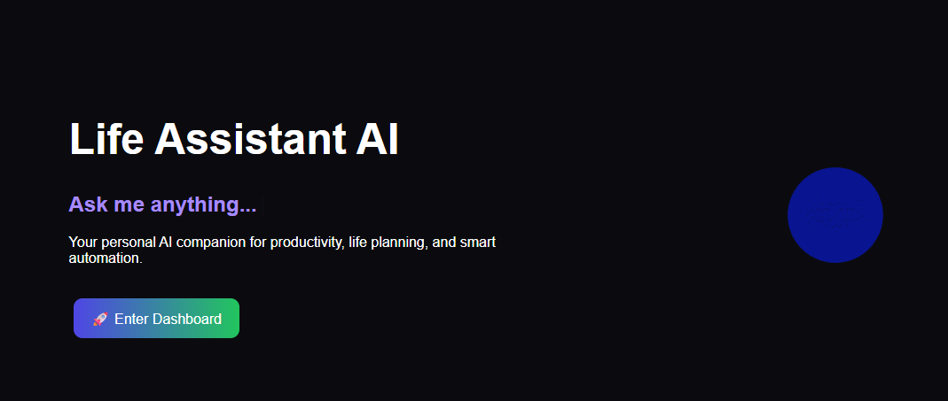

N

2. HeroClass:

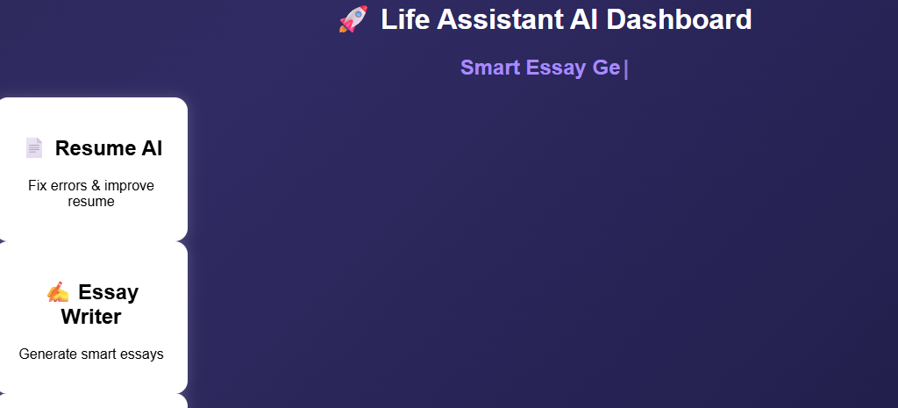

3.Resume Dashboard:
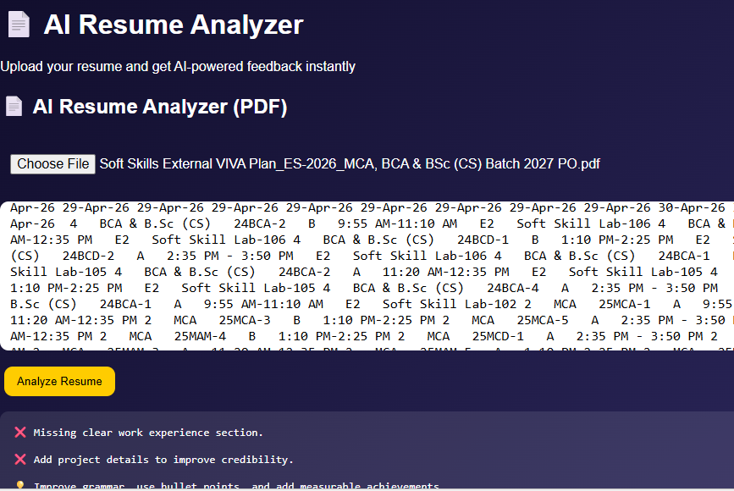

4.Essay Dashboard:
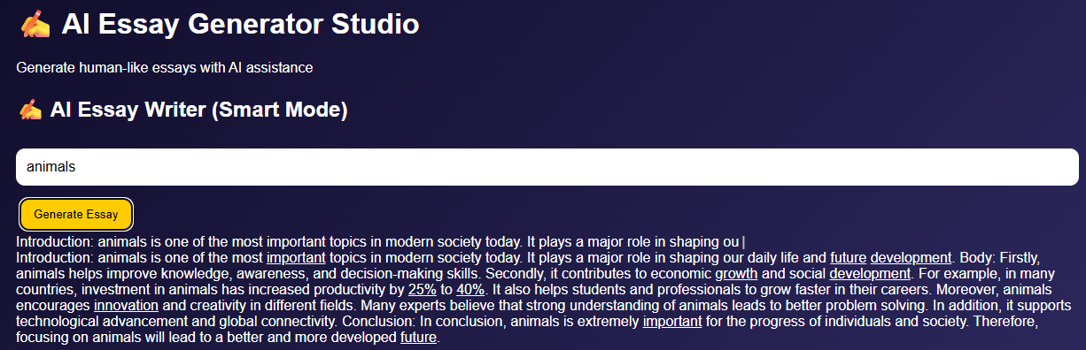

5.Kids Dashboard:
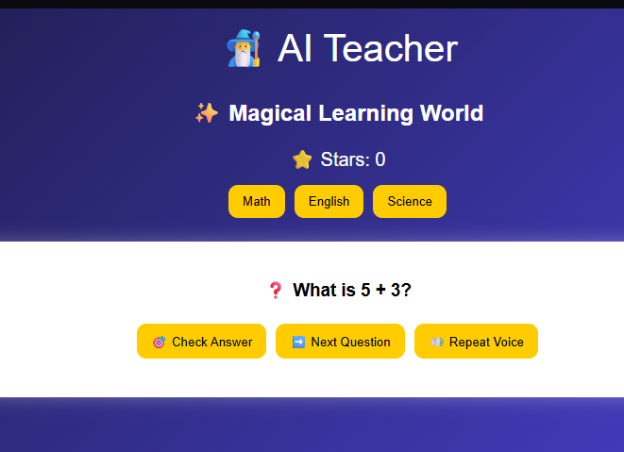

5.DATABASE CONNECTION :

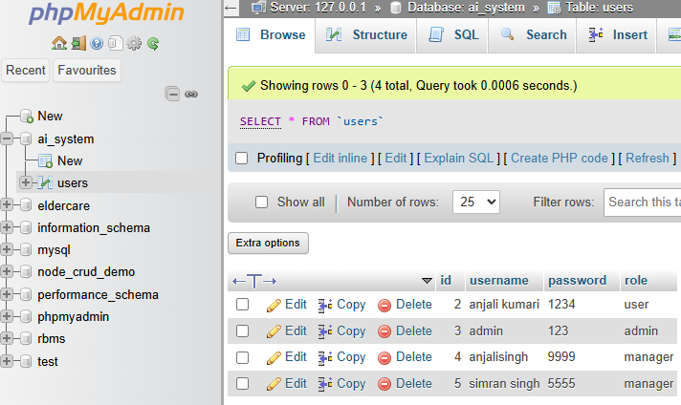

: Future Enhancements

1. Advanced UI/UX Improvements
- Improve frontend design with modern UI themes
- Add animations and smooth transitions
- Make interface more user-friendly and responsive

2. Advanced Component Structure
- Break UI into reusable components
- Improve code maintainability and scalability
- Follow modular frontend architecture

3. Performance Optimization
- Optimize loading speed of web pages
- Reduce unnecessary API calls
- Improve rendering performance using lazy loading

4. State Management Upgrade
- Use advanced state management tools like Redux or Context API
- Improve data flow between components
- Enhance application efficiency

5. API Integration Enhancement
- Connect frontend with advanced backend APIs
- Improve real-time data fetching
- Enable dynamic content updates

6. Security Improvements
- Add authentication and authorization layers
- Secure frontend-backend communication
- Protect against XSS and injection attacks

7. Mobile Responsiveness
- Improve UI for mobile and tablet devices
- Ensure cross-device compatibility
- Use responsive design frameworks effectively

CONCLUSION

The Life Assistant AI system successfully demonstrates how artificial intelligence can be integrated into a modern web application to improve productivity, learning, and user interaction. It combines multiple intelligent modules such as resume enhancement, essay generation, multilingual translation, and interactive kids learning into a single unified platform.
The system provides a user-friendly dashboard that allows easy navigation between different AI tools while maintaining a clean and responsive interface. By using AI-driven features, the application helps users improve writing quality, understand concepts better, and perform tasks more efficiently.
In addition, features like voice interaction, animated UI, and multilingual support enhance accessibility and user engagement. The modular structure of the system ensures scalability, allowing future improvements such as advanced AI chatbots, personalized learning paths, and real-time assistance.
Overall, the Life Assistant AI project demonstrates the practical application of AI in education and productivity systems, making it a powerful and intelligent assistant for users in academic and real-world scenarios.

References

- www.github.com
- www.google.com
- www.youtube.com

Github link and Screenshot .

Link: https://github.com/anjalikumari21jsr-art/AI-smart-game-.git

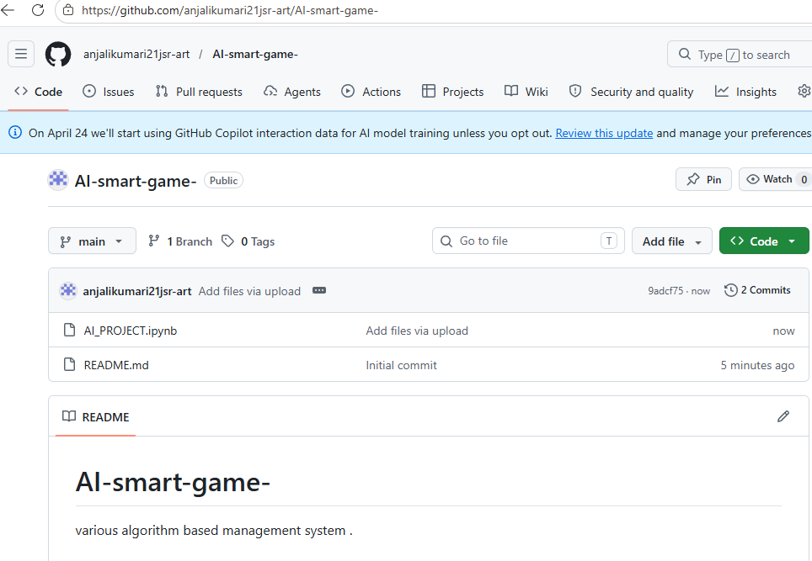

Deployment:

